Developing an Integrated Care Partnership in Leeds – Progress, proposals and next steps

Report of: Leeds Health and Care Partnership Executive Group (PEG)
Date: Version 9, 05/03/21

Purpose
This paper has been written by the Leeds Health and Care Partnership Executive Group (PEG) whose members include: the CEOs from the NHS in Leeds; Leeds City Council (LCC); Healthwatch; Directors of Adults and Health, Childrens and Families; Public Health; and advocates from the 3rd sector, General Practice and Clinical Senate.
This paper will be used to support discussions with Boards and executive teams to:
- Affirm commitment to the shared purpose and degree of ambition set out in the Leeds Health and Wellbeing Strategy and measured through a shared set of outcomes and measures.
- Gain a mandate to scope the establishment of a Leeds Integrated Care Partnership (ICP) and underpinning governance arrangements, including a formal partnership agreement and/or joint committee.

- Confirm Board support for the establishment of a set of shared integration functions and capabilities for the city as a key component of a proposed ICP.

Recommendations
It is recommended that Boards:
Recommendation 1 – Reaffirm support for our shared ambition as measured by the strategic indicators described within the city’s Left Shift Blueprint.
Recommendation 2 – Commit their organisations to a further degree of integration by tasking their leaders to scope, define and propose arrangements for a Leeds ICP.
Recommendation 3 – Provide support in principle to the creation of a partnership agreement and/or joint committee that has delegated powers to underpin and enable the Leeds ICP.
Recommendation 4 – Provide sign-up to securing a co-ordinating/integrating set of capabilities in the city through a dedicated ICP function and commitment to doing things once where it makes sense to do so.
Recommendation 5 – Sign-up to a specific relationship with the ICP, as a constituent part of the ICS, that takes responsibility for the discharge of duties in Leeds (as opposed to duties being discharged separately to the ICP).

Achieving our ambition

3.1 Our shared ambition
Our Leeds Health and Wellbeing Strategy has set the focus of our partnership that together we will make Leeds the best city in the UK for health and wellbeing, a healthy caring city for all ages, where the poorest improve their health the fastest. The best city for all ages, both now and for future generations.
Despite some fantastic work to date, good health and prosperity in our city is still not felt by all and there is evidence that some inequalities are widening and will worsen as a result of the Covid pandemic. Making Leeds a more equal city with more people benefiting from the life chances currently enjoyed by the few is at the heart of our vision. This is why we emphasise the importance of good health, the need to boost resilience, and focusing on prevention as a means of enabling higher quality, person-centred service provision.
A social model of health is fundamental to prevention of poor physical and mental health, which take into account influences on health and wellbeing, including social, cultural, economic, and environmental factors. We believe that people are the catalysts for change in their local communities and within the front-line and should be actively involved in identifying, planning, designing and implementing solutions to health issues and unjust health inequalities. Strategic alliances of individuals, communities, services, professionals and local councillors, will be used and developed further to support this shift.
Improving health services needs to happen alongside achieving financial sustainability, making the best use of the collective resources, and working more purposefully in an integrated way to ensure we improve the health and wellbeing of the people of Leeds.

3.2 Delivering our ambition
Having a shared ambition is only part of the picture. We need a clearly defined and shared work programme to collectively own and deliver. This work programme also needs outcomes and indicators that are jointly owned and which can be used to measure our success not just in the here and now but also improving the health and wellbeing of the Leeds population over a longer time period.
In November 2019, NHS Leeds CCG committed on behalf of the partners to lead the development of the ‘Left-shift Blueprint’ as one of the contributions towards delivering our collective partnership ambition. Over the last 12 months, as a partnership, we have developed the ‘Left-shift Blueprint’ which sets out how health and care services will be delivered in Leeds over the next five years.
Whilst this work is essential to ensuring a coherent approach to improving health and wellbeing outcomes across the city, it is even more critical that it is undertaken now given the planned initiatives to rebuild hospital estates and to understand and address the impact of the pandemic on health outcomes and health inequalities. It is essential that through the ‘Left-shift Blueprint’ we develop an agreed model of care for the city which drives health improvement, meets future demand and can also be delivered within our future estates footprint. The ‘Left-shift Blueprint’ sets out our system wide ambitions through three types of strategic indicators.
- Health outcome ambitions – these are longer term indicators looking at over a 10 year period
- System activity metrics – these indicators will provide a more immediate view of impact and will be measured through the Leeds Data Model
- Quality experience measures – these will use a balanced scorecard approach using a mixture of user voice: Healthwatch and other user-led feedback mechanisms, compliments and complaints information, multi-agency and multi-disciplinary case file audits, and metrics. It is important that these reflect experience from a population rather than just a service perspective.
It is proposed that for each of these strategic indicators, our ambition is to:-
- Be as good as, if not better than the England average
- Where measurement allows – we will commit to reducing the gap between Leeds and deprived Leeds by 10%
These specific targets and metrics have been developed and selected due to their impact and span across our populations in terms of our ability to influence and deliver across health and care pathways. The various programme boards have played a significant role in helping shape these. Wherever possible effort has been to ensure clear links to other existing and emerging delivery models across the health system (such as Building the Leeds Way and the development of the Primary Care Networks (PCN) and Local Care Partnerships (LCP)) in order to retain cohesion across sectors in our delivery aims. An overview of the strategic indicators as developed to date are provided in Appendix 1.
The particular health outcome ambitions are set out below.
Measurable improvement across these strategic indicators will be driven by clinicians, professionals, 3rd sector and people of Leeds using Population Health Management (PHM) approaches and local insight (at LCP and city level) to identify, design and implement interventions and service change that will have the biggest impact. In-line with our Health and Wellbeing Strategy ethos of starting with people and communities, we will ensure that coproduction runs through all aspects of change. Clinical and professional leadership at place level (through the Clinical Senate), at programme level (through named clinical and professional leads at programme and Programme Board level) and at LCP level (through multi-professional LCP teams) will be critical to successful delivery of our ambition.

Recommendation 1 – Boards are asked to reaffirm support for our shared ambition as measured by the strategic indicators described within the city’s Left Shift Blueprint.

4. Proposal to create a formal Integrated Care Partnership for Leeds

4.1 Our partnership and journey towards integrated care
Leeds has a long history of successful partnership working with people at the heart and with a breadth of assets to enable genuine whole system change. There are many examples of how, by working together as a partnership, we have achieved successes and improvements to lives of people who live and work in Leeds. Some examples are provided in the diagram below.

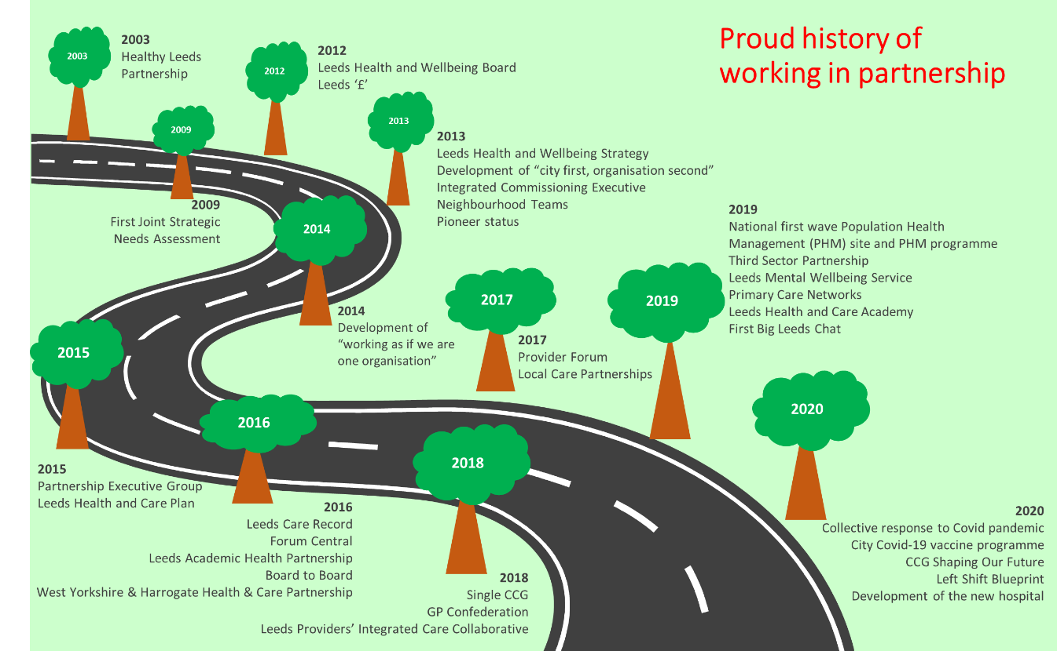

Most recently, the response to the Coronavirus pandemic across the city has once again demonstrated what can be achieved when heath and care staff from different organisations and different roles work together, alongside communities, to achieve shared goals. There is a strong consensus that our response to the pandemic offered an opportunity around integrated clinical working and clinician engagement that coincides with an ambition to develop an ICP and progress health and care integration.
Building on this success, we want to proactively create the conditions that enable and support our health and care staff from all professions to continue to work together, and with people and communities, to deliver measurable progress towards our ambition to improve outcomes and reduce inequalities for our population.

4.2 Proposals for an Integrated Care Partnership for Leeds
There is opportunity to develop and enable closer working relationships and practice by establishing more formal integrated care partnership arrangements in Leeds.
The proposed legislative changes outlined in the February 2021 Health and Social Care White Paper and the associated development of the West Yorkshire & Harrogate ICS (WYHICS) Operating Model strengthen the case for formalising integrated care partnership arrangements in Leeds.
From April 2022, ICSs will become statutory organisations absorbing commissioning functions currently undertaken by CCGs and NHS England. Strong place based arrangements (Integrated Care Partnerships) are the cornerstone of the emerging WYHICS Operating Model (depicted in Figure 1 below).

Figure 1 – Proposed Operating Model for WYHICS and what a Leeds ICP could be
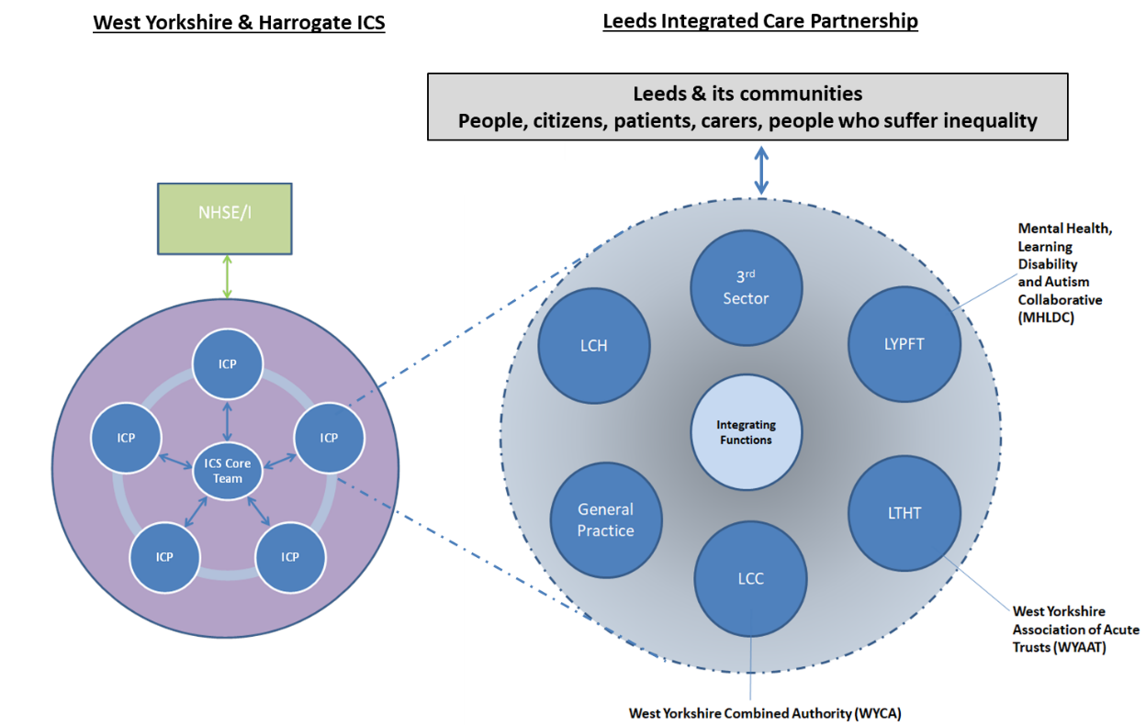

Central to the proposed WYHICS Operating Model is that ‘Place’ is the primary unit of planning and collaboration, with place-level partnerships working closely with local Health and Wellbeing Boards. Joint committees between the members of Integrated Care Partnerships and Provider Collaboratives will enable more integrated working and mean that ICPs and Provider Collaboratives will be able to discharge the duties of an ICS at place level. Continuing to have a strong place based approach is essential to delivering high quality person centred care, working with people at a neighbourhood (LCP) level.
Within the context of our shared ambition, our track record of collaboration and integration and the opportunities afforded through national reform; a Leeds ICP could be described as:
“An alliance of health and care partners that work together to improve the health outcomes and reduce inequalities of the population by using our resources collectively to deliver population-health driven integrated care”.
The formalising of existing partnership arrangement into a Leeds ICP would help us achieve measurable delivery of our shared ambition (as set out in the ‘Left Shift Blueprint’) by enabling us to jointly plan and agree how we use our collective resources to enable clinically-led design and implementation of initiatives and services that improve quality, clinical effectiveness and people’s experience.
Establishing a place level ICP for Leeds also creates an opportunity to connect Population Health Management (PHM) approaches at place and Local Care Partnership level, to enable resources to be directed to populations (geographical and needs-based) where the greatest opportunities for improvement exist. There are opportunities to create a citywide improvement capability with shared methods and data to improve value and quality across care pathways. For meaningful change, clinical leadership and engagement is essential; citywide ambitions and improvement activity need to be applicable to all health and care staff so that those who are doing the work can improve the work. It is also important to work with the research and academic sector to apply skills and expertise the sector can bring to innovation. As depicted in Figure 1, the WYHICS Operating Model is constructed around place-level ICPs supported by an ICS core team. Within this model, a Leeds ICP would operate with sufficient autonomy to remain focussed on the delivery of our ambition for Leeds whilst retaining its membership as part of the wider WYHICS.
Work is required to scope, define and propose arrangements for a Leeds ICP clearly articulating how these arrangements will better enable us achieve our ambition within our collective available resources.

4.3 Engagement and coproduction
Creating a culture of collaboration around a shared vision through engagement with our teams, and the people of Leeds, will be key to making meaningful change. Leeds’s successful partnership has been in part due to the way all partners are engaged with the aim to coproduce and have people’s voices at the heart. It is recommended Leeds embarks on an ambitious ‘Team Leeds’ engagement programme to coproduce the future ‘integrated care partnership’, the principles and the culture with both staff (including clinicians and the 3rd sector) and the public. It is proposed that the staff element is led by the Strategic Workforce Programme and the public element is led by Healthwatch with both elements supported by the Health Partnerships Team.

Recommendation 2 – Boards are asked to commit their organisations to a further degree of integration by tasking their leaders to scope, define and propose arrangements for a Leeds Integrated Care Partnership

4.4 Creating of a Partnership Agreement / Joint Committee
Legislation proposed in the recent White Paper specifies that to enable Integrated Care Partnerships to discharge duties on behalf of the ICS, there must be a ‘weight bearing’ partnership agreement and/or joint committee at the (Leeds) place level to underpin the ICP.
The arrangements set out within a partnership agreement will be designed to further strengthen relationships between partners within the Leeds ICP, all of whom are strategic planners (commissioners) and/or providers of health and care services in Leeds, for the benefit of the population of Leeds. The arrangements will also enable the ICP to operate with a level of autonomy required to act and make decisions to enable the ICP to fulfil its purpose and deliver its ambition. Specifically this would include the ability to manage the delegated budget for the city to enable delivery of agreed priorities.
The ambition will be that the ICS provides sufficient support through former CCG colleagues to ensure that the ICP can move quickly to ensure it is able to discharge the ICS duties at place. Our CCG colleagues who are already embedded in the city and our ICP development work will continue to be so regardless of changes in the statutory organisation that employs them. The ICP will identify those areas where it believes the ICS will add additional value by undertaking them once across West Yorkshire.
A key area to be agreed is the membership model for the Leeds Integrated Care Partnership. Membership will need to include both statutory health and care organisations and non-statutory partners (covering the 3rd sector, independent sector and statutory sector) recognising the whole partnership approach we have in Leeds. Initial thinking based on learning from other areas is to have two categories of membership – “full member” and “associate member”. The membership type will likely be determined by how organisations are constituted and their statutory authority. All members will be able to input to any discussions requiring a decision, but decisions concerning statutory NHS requirements are only taken by full members. However, both full and associate members will be equally committed to delivering the objectives of the ICP.
It is proposed that members of the Leeds ICP will work together under a governance framework (set out in a partnership agreement) to develop place-based arrangements to enable the collective planning and delivery of person centred integrated care. These arrangements may ultimately include requirements in relation to outcomes, risk/gain share, financial and contract management and regulatory requirements. The agreement will also include a financial framework to allow pooling of resources and ensuring there is system visibility of budgets where there is no direct alignment or pooling to ensure that decisions take account wider system implications.
The emerging Operating Model for the WYHICS proposes that appropriate governance arrangements should be in place, in shadow form, from September 2021. As changes to the national legislation will take many months to be developed and enacted, there may be a need to iterate any local governance arrangements once changes to legislation are made. Appendix 2 provides a high level overview of potential content of a partnership agreement.

4.5 Relationship with existing organisational governance in Leeds
As part of the development of the ICP and underpinned by a formal agreement, it is important to note that:
- Existing individual Boards will retain accountability and responsibility for individual organisations but will have chosen to work together in specific ways on specific programmes and delivering a set of shared capabilities.
- Boards are doing this because they believe that by working more formally together we will deliver the shared purpose and ambition.
- The Leeds Health and Wellbeing Board will continue to lead partnerships in Leeds and fulfil its statutory functions to produce a Health and Wellbeing Strategy, Joint Strategic Needs Assessment and promote integration.
- The WYICS Operating Model is founded on the principle that the ICPs are the place-based units of the ICS. Individual organisations and the integrated care partnership will contribute to and thus have regard to plans set by the ICS.
- The future relationship between the ICP and the Leeds Health and Care Partnership Executive group needs to be defined.
- The review of ICP governance arrangements creates a useful opportunity to review the wider partnership governance and to streamline where appropriate.
Work is required to understand, scope and recommend options regarding the membership and form of partnership agreement and/or joint committee to underpin the Leeds ICP. This will require collaborative working with governance leads from organisations across the Leeds health and care system as well as input from legal experts.

Recommendation 3 – Boards are asked to provide support in principle to the creation of a partnership agreement and/or joint committee that has delegated powers to underpin and enable the Leeds Integrated Care Partnership

Securing a co-ordinating/integrating set of capabilities in the city

5.1 Shared capabilities
Successful integrated health and care systems from across the world have in common, a set of coordinating or integrating capabilities. The existence of these capabilities allows each partner to both retain a level of organisational autonomy whilst coming together where it makes to do so to jointly deliver the shared ambition in a consistent efficient way.
As part of the aforementioned legislation, from April 2022, functions undertaken by CCGs will be undertaken by ICSs and CCGs will no longer exist. Through its Shaping Our Future programme (SOF) NHS Leeds CCG has redesigned the way it will operate from a traditional commissioning organisation to an organisation able to use Population Health Management approaches to deliver Strategic Planning and System Integration capabilities in its future capacity.
As part of the emerging WYICS Operating Model, CCG staff will continue to work and be embedded in Leeds to deliver a set of value-adding integrating capabilities to the ICP, as well as ensuring the ICP is capable immediately of discharging in place the duties of an ICS.
Figure 2 – Integrating functions as part of the Leeds Integrated Care Partnership
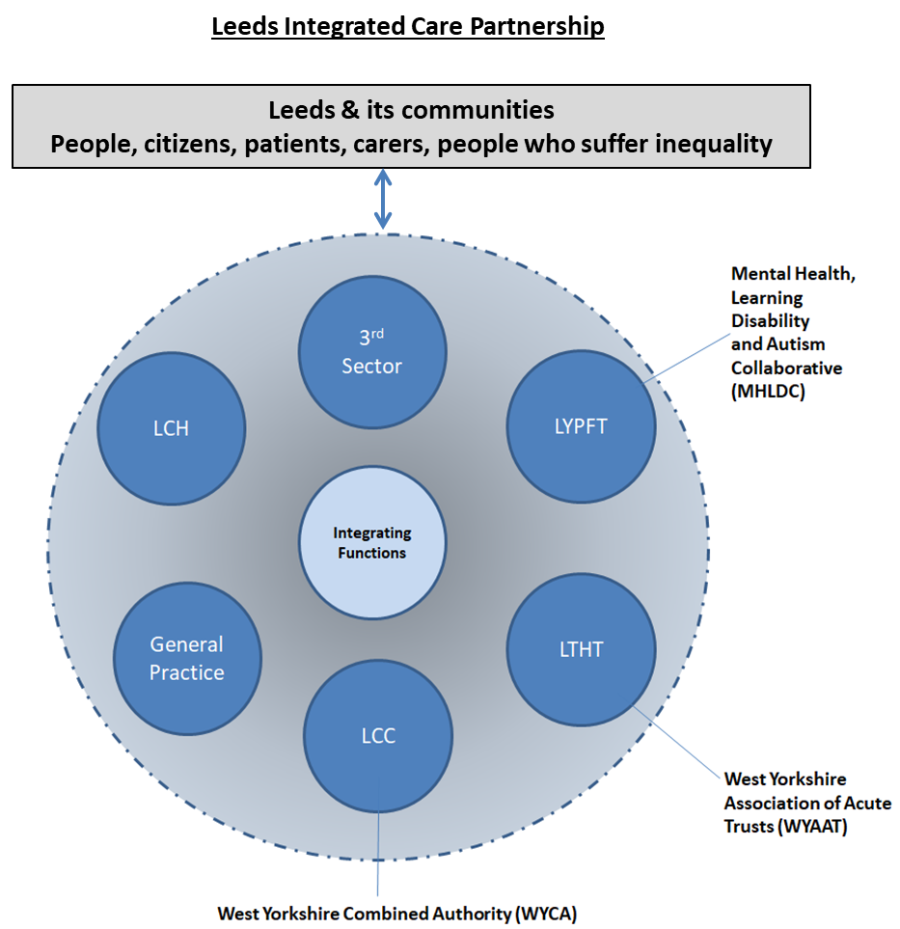

Though the former CCG staff play a key role in the integrating functions, it is important that all partners play a role in the different integrating functions and that there is strong alignment with all partners. A high level summary of the integrating / coordinating capabilities which could be established are described in Figure 3. The CCG through its Shaping Our Future programme is already in process of developing many of these capabilities ahead of any changes in legislation. A fuller description can be found in Appendix 3.

Figure 3 – Joint integrating / coordinating capabilities
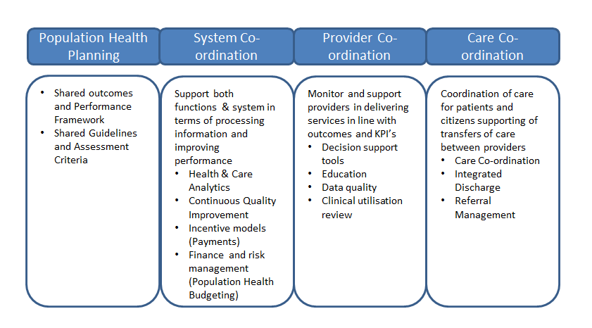
It is important to note that establishing this full range of capabilities for the ICP will require time and in some cases technical development. Time limited external expertise may be required to understand the priorities for capability development and also to provide targeted technical support in the development of some of these capabilities.
Recommendation 4 – Boards are asked to provide sign-up to securing a co-ordinating/integrating set of capabilities in the city through a dedicated ICP function and commitment to doing things once where it makes sense to do so.

5.2 Relationship with West Yorkshire and Harrogate Integrated Care System
Leeds is a strong supporter of the devolved place based leadership approach we have adopted across the region and the principle of subsidiarity with work taking place at the appropriate level and as near to local as possible. We know from engaging with the public and staff, there is a much stronger connection to place and local community rather than an ICS body which can feel much more distant to the front-line.
By implementing the proposals set-out in this paper, Leeds will be in a strong position to support the ICS to discharge its duties through a place based model.
Leeds is and will continue to be an active member of the West Yorkshire and Harrogate Integrated Care System (ICS) to improve health and healthcare across the wider region. Leeds has taken leadership roles across the ICS for example, Chairing the West Yorkshire Association of Acute Trusts (WYAAT), Chairing the Mental Health, Learning Disabilities and Autism Provider Collaborative (MHLDC), as well as taking on sector rep roles for local authority which will strengthen this approach and alongside this our contribution to West Yorkshire wide programmes.
Recommendation 5 – Boards are asked to sign-up to a specific relationship with the ICP, as a constituent part of the ICS, that takes responsibility for the discharge of duties in Leeds (as opposed to duties being discharged separately to the ICP)

Next steps
A significant amount of work is required to explore, scope and propose options around the constitution, governance and membership of a Leeds ICP. This work will require a significant contribution from all partners at place level and will also need to develop within the context of the evolving ICS Operating Model and national legislation.
It is proposed that existing partnership structures will need to be adapted to establish an Integrated Care Partnership Development Programme Board with CEO / Accountable Officer level membership from the NHS, LCC, 3rd sector, Healthwatch and clinical representation to drive forward the development of a Leeds ICP. The Programme Board will need to engage with Governing Boards at each stage of the development of the proposals to ensure that they progress with the support of the partnership.
The following is the outline of the next steps.
Citywide ‘hearts and minds’ engagement and co-production process | March – July 2021
Agree a range of priority programmes for the first twelve months that reflect our health ambitions and the development of ICP | April 2021
Sign-off of a formal collaboration agreement | May 2021
Joint Committee in place in shadow form | June 2021
Describe the approach to delivering the integrating / coordination functions in Leeds | June 2021
Joint Committee formally established | September 2021

Appendix 1
Proposed system level outcomes and indicators
The ‘Left Shift Blueprint’ proposes the following system wide ambitions through three types of strategic indicators.
- Health outcome ambitions – these are longer term indicators looking at over a 10 year period
- System activity metrics – these indicators will provide a more immediate view of impact and will be measured through the Leeds Data Model
- Quality experience measures – This will use a balanced scorecard approach using a mixture of user voice: Healthwatch and other user-led feedback mechanisms, compliments and complaints information, multi-agency and multi-disciplinary case file audits, and metrics. It is important that these reflect experience from a population rather than just a service perspective.
It is proposed that for each of these strategic indicators, our ambition is to:-
- Be as good as if not better than the England average
- Where measurement allows – we will commit to reducing the gap between Leeds and deprived Leeds by 10%.
An overview of the strategic indicators as developed to date are described in the diagram below. These will be refined through further engagement with partners.
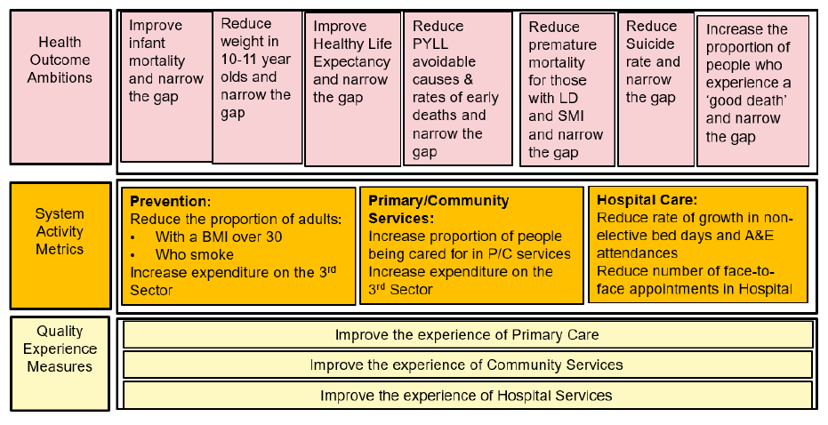

Appendix 2

Outline partnership agreement
If Boards support the recommendations outlined in this paper, then it is likely that a partnership agreement will need to cover the following:
- Those the agreement is made between, includes full and associate.
- The background, any context and reasons for the agreement
- Definitions and interpretations
- Status and purpose of the agreement
  - Sets out the main reasons for the agreement and what parties have signed up to do.
- When the agreement commences and duration
- Vision
  - That of the Leeds Health & Wellbeing Strategy
- Objectives
  - A combination of the Leeds Health & Wellbeing Strategy and Left Shift Blueprint
- Principles of collaboration
  - The way the collaboration will work together, decisions it will make and behaviours
- Problems, resolution and escalation
- Reserved Matters
  - Where there are statutory duties a members has to comply with outside of the agreement
- Transparency
- Obligations
  - Includes the obligations of full and associate members
- Governance agreements
  - The architecture, decision making responsibility. What different groups, committee, boards are responsible for
- Conflicts of interest
- Financial planning
- Exclusion and termination
- New members
- Liabilities
- Variations
- Confidentiality
- Intellectual property
- Schedules
  - Definitions
  - Priority areas
  - Principles
  - Implementation
  - Governance TORs
  - Rights and obligations of full and associate members
  - Dispute resolution

Appendix 3

Changes the CCG is making to support the development of co-ordinating/integrating capabilities
Population Health Planning | - Outcomes: The Director of Population Health Planning (recently appointed by the CCG) has a value adding offer that is linked to shared outcomes and performance.  - Data Architecture: The joint Chief Digital Officer between LCC and the CCG is starting the development of proposals to create an office of data analytics and ensure that common data architecture is in place.
System Co-ordination | - Quality Improvement: Establishment of citywide quality improvement capability, combining existing experience from use of the Institute for Healthcare Improvement, LTHT Leeds Improvement Method and the CCG Quality Improvement Team. This capability can help create high quality care and value across pathways and help establish citywide methods and capability for improvement.  - Incentive Models: A capability to manage the commercial relationships between partners within the partnership including development of incentives and importantly to ensure general practice management is retained in Leeds  - Finance and Risk Management: Teams to support the ICP to manage overall financial position independently and value adding capabilities around understanding population health and financial risk – population health budgeting  The CCG has also identified:  - support for governance requirements which will sit alongside organisational governance  - support for development and implementation of ICP policies in smaller members of the partnership that don’t have the capacity at a broader level  - support to develop and maintain a roadmap on the journey towards integration
Provider Co-ordination and care Co-ordination | Pathway integration functions are designed to pick-up many of these capabilities and able to flex in the future whilst recognising that the NHS will still like named leads for key areas such as Cancer or Mental Health.  Capacity around training and development has not been included as the city already has the Leeds Health & Care Academy. However, what is more radical in international examples is that care co-ordination is a key function not placed in any individual provider as we currently operate it. This is not set out in detail in the CCG design as will need further discussion across the partnership.

Home to: NHS England/Improvement; NHS Digital; several of the world’s leading health technology and information companies; one of Europe’s largest teaching hospitals; many good or outstanding services and providers; being one of the first integrated care Pioneers; Council recognised as a Department for Education Partner in Practice; one of four ‘first wave’ national Population Health Management (PHM) sites; several leading universities; a diverse and thriving third sector; and a GP Confederation - a membership organisation that comprises of all 19 Primary Care Networks, with the governance that allows for integration and collaborative working with other providers
Integration and Innovation: working together to improve health and social care for all (publishing.service.gov.uk)

